kojie.san: Holiday Millionaire
Promo Mechanics and Terms & Conditions

I. PARTICIPATION CRITERIA
1. The “kojie.san: Holiday Millionaire” gives you the chance to win daily Instant GCash Vouchers up to Five Hundred (500 PHP), worth 500 PHP, and BEVi Products. For the major prize, 2 winners of tax-inclusive One Million pesos (1,000,000 PHP) in the Grand Draw will be chosen.
2. Promo is open to Philippine citizens and all people residing in the Philippines. For the major prize, employees and family members of BEVi – Beauty Elements Ventures Inc., BEVi Asia Pacific, BEVi Manufacturing Inc., Breedwinner, Empro Leasing Properties, One Stand Point (OSP), Philippine Bottle Beverages, and affiliated agencies, including their relatives up to the second degree of consanguinity and affinity, are not eligible to win.
3. Participants must have reached the age of eighteen (18) years as of 2025.
4. Participants to be eligible to have an entry must buy any participating Kojie San products in the participating stores with a minimum purchase of 100 PHP.
5. Participants must scan the QR code on kojie.san’s in-store promotional materials or go to kojie.san’s Official Facebook page and register their Name, Address, Contact Number, and a photo of Proof of Purchase (Official Receipt from Trade stores).

II. PARTICIPATING PRODUCT(S)
List of Participating Kojie San Product(s):

PRODUCT NAME | SIZE
KOJIE.SAN SKIN LIGHTENING CLASSIC SOAP | 135G
KOJIE.SAN SKIN LIGHTENING CLASSIC SOAP | 65Gby2
KOJIE.SAN SKIN LIGHTENING CLASSIC SOAP | 45g
KOJIE.SAN SKIN LIGHTENING CLASSIC SOAP | 135Gby2
KOJIE.SAN SKIN LIGHTENING CLASSIC SOAP | 65Gby3
KOJIE.SAN SKIN LIGHTENING CLASSIC SOAP | 100Gby3
KOJIE.SAN SKIN LIGHTENING CLASSIC SOAP FAMILY PACK | 135Gby6
KOJIE.SAN SKIN LIGHTENING HYDROMOIST SOAP | 135G
KOJIE.SAN SKIN LIGHTENING CLASSIC SOAP FAMILY PACK | 100Gby6
KOJIE.SAN SKIN LIGHTENING CLEANSER+TONER WITH HYDROMOIST | 100ML
KOJIE.SAN SKIN LIGHTENING PORE MINIMIZING TONER WITH HYDROMOIST | 100ML
KOJIE.SAN SKIN LIGHTENING FACE CREAM WITH HYDROMOIST | 30G
KOJIE.SAN SKIN LIGHTENING FACE CREAM SPF15 WITH HYDROMOIST | 22G
KOJIE.SAN TINTED SUNSCREEN SPF50 PA+++ | 50G
KOJIE.SAN SKIN LIGHTENING FACIAL WASH WITH HYDROMOIST | 100G
KOJIE.SAN SKIN LIGHTENING SUPER SERUM SACHET | 7.5ML
KOJIE.SAN SKIN LIGHTENING SUPER SERUM | 30ML
KOJIE.SAN SKIN LIGHTENING BODY LOTION WITH HYDROMOIST | 100G
KOJIE.SAN SKIN LIGHTENING BODY LOTION WITH HYDROMOIST | 200G
KOJIE.SAN SKIN LIGHTENING BODY LOTION SPF25 WITH HYDROMOIST | 150G
KOJIE.SAN SKIN LIGHTENING BODY LOTION SPF25 WITH HYDROMOIST | 250G
KOJIE.SAN SKIN LIGHTENING BODY WASH WITH HYDROMOIST | 300ML
KOJIE.SAN DREAMWHITE ANTI-AGING SOAP | 135G
KOJIE.SAN DREAMWHITE ANTI-AGING SOAP | 135Gby2
KOJIE.SAN DREAMWHITE ANTI-AGING SOAP | 65Gby2
KOJIE.SAN DREAMWHITE ANTI-AGING FACIAL TONER WITH COLLAGEN | 60ML
KOJIE.SAN DREAMWHITE ANTI-AGING FACIAL TONER WITH COLLAGEN | 100ML
KOJIE.SAN DREAMWHITE ANTI-AGING CREAM WITH SUNSCREEN SPF30 | 30G
KOJIE.SAN DREAMWHITE ANTI-AGING OVERNIGHT CREAM | 30G
KOJIE.SAN MEN LIGHTENING FACE AND BODY SOAP | 135G
KOJIE.SAN MEN EXTRA FRESH FACE AND BODY SOAP | 135G
KOJIE.SAN MEN LIGHTENING BODY WASH | 300ML
KOJIE.SAN MEN OIL CONTROL FACE WASH | 125G
KOJIE.SAN MEN EXTRA COOL FACE WASH | 125G
KOJIE.SAN SUNPROTECT SPF50+ PA+++ FACE SACHET | 15G
KOJIE.SAN SUNPROTECT SPF50+ PA+++ FACE | 50G
KOJIE.SAN SUNPROTECT SPF50+ PA+++ SPORT SACHET | 15G

III. PARTICIPATING STORE(S)
TRADE STORES:
LIST OF ACCOUNTS
1 2 Brothers Supermarkets
2 St. Joseph Pharmacy
3 All Day Supermarket
4 Alturas Group of Supermarket
5 Bohol Quality
6 Budget King
7 Budgetwise
8 Cash and Carry
9 Cheer's
10 Citimart
11 Colonnade
12 DiviMart
13 EBG Supermarket
14 Emil US
15 Ever Supermarket
16 Everwin
17 FCC Supermaket
18 Felcris
19 Fisher Mall
20 Gaisano Brothers
21 Gaisano Capital
22 Gaisano Grand
23 Gaisano Mall
24 Goodwill
25 HI-Top
26 Iloilo Supermarket
27 Imart
28 Isetann
29 Jeanees
30 JS Gaisano
31 JTC Supermarket
32 KCC Mall
33 Kemp Group
34 La Nueva
35 La Suerte
36 Landers
37 LCC Supermarket
38 LCC Department Store
39 LEE Supermart
40 Lianas Supermarket
41 Lots for Less
42 Makati Supermart
43 Mariton
44 Metro Gaisano
45 MOFAR Grocery
46 NCCC Supermarket
47 Newstar
48 Ongville
49 Ororama
50 Prime Supermarket
51 Prince
52 Reysal
53 San Roque Supermarket
54 Savewise
55 Simplicity
56 Southern Twin
57 STM Supermarket
58 Superama
59 Talavera
60 Tiongsan
61 Topway Group
62 Tropical Hut
63 Unimart
64 Unimec
65 Unitop
66 Vallecer
67 Victoria
68 Wrap & Carry
69 Xocio
70 Yubenco
71 7-eleven
72 Lawson
73 Uncle John's
74 Alfamart
75 Merry Mart
76 Landmark
77 Sound Supermarket
78 Rose Pharmacy
79 Southstar Drugstore
80 Mercury Drugstores
81 Puregold
82 Robinsons Easymart
83 Robinsons Supermarket
84 Shopwise
85 SM Savemore
86 SM Hypermarket
87 SM Supermarket
88 The Marketplace - Rustans
89 Waltermart
90 Watsons Personal Care

IV. PROMO PERIOD AND SCHEDULE OF VALIDATION, DRAW DATE, AND ANNOUNCEMENT OF WINNERS
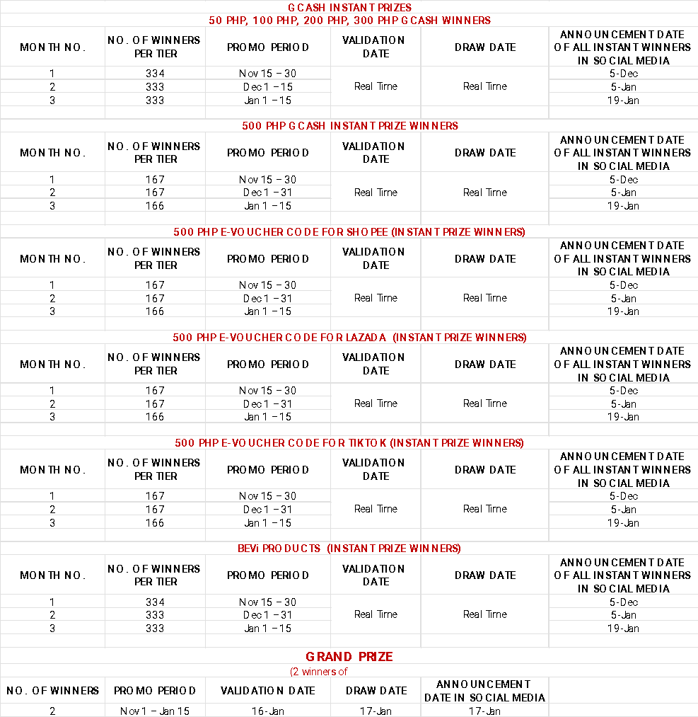
*Note: Instant prize winners will be informed of their prize in real-time once the system has validated their entry

V. HOW TO JOIN THE PROMO
1. The Participant must buy any participating kojie.san products at any participating stores nationwide with a minimum purchase of 100 php.
2. To register, participants can scan the QR code at kojie.san’s in-store promotional materials or message the kojie.san’s Official Facebook page and must register and upload their receipt. They need to register their Name, Address, Contact Number, and a photo of Proof of Purchase (Official Receipt for Trade stores/ Screenshot of Online Store Order Details).

VI. PRIZES
Prizes are not convertible to cash and are non-transferable.
Prizes to be given away:
INSTANT PRIZES
Eligibility: To qualify for Instant Prizes, participants must present proof of purchase showing a minimum of ₱100 worth of participating kojie.san products. Purchases below ₱100 are not eligible for Instant Prizes.

GCASH voucher:
- One Thousand (1,000) winners of a Fifty pesos (50 PHP) GCash Voucher
- One Thousand (1,000) winners of a One Hundred pesos (100 PHP) GCash Voucher
- One Thousand (1,000) winners of a Two Hundred pesos (200 PHP) GCash
- One Thousand (1,000) winners of a Three Hundred pesos (300 PHP) GCash Voucher
- One Thousand (500) winners of a Five Hundred pesos (500 PHP) GCash Voucher

BEVi PH Online Stores Electronic Discount Voucher:
- Five Hundred (500) winners of Shopee Discount Code Voucher
- Five Hundred (500) winners of Lazada Discount Code Voucher
- Five Hundred (500) winners of TikTok Discount Code Voucher
*Note: these vouchers can only be used at BEVi PH online stores

BEVi Products
• One Thousand (1,000) winners of products under BEVi Beauty Elements Ventures Inc.

MAJOR PRIZE (Grand Draw):
Eligibility: The Major Prize (₱1,000,000 each for 2 winners) is open only to qualified participants who have registered valid entries during the promo period with a minimum purchase of ₱100 worth of participating kojie.san products, and who are not employees of BEVi or its affiliated companies, agencies, and their relatives up to the second degree of consanguinity or affinity.
• Two (2) Winners of One Million Pesos each (1,000,000 PHP)

VII. DETERMINATION OF WINNERS
1. Participants must register from November 15, 2025, to January 15, 2025 (11:59 PM).
2. All entries will be collected through kojie.san’s Official Facebook Page (Messenger).
3. All entries will be screened by BEVi Beauty Elements Inc., BEVi Asia Pacific’s in-house Digital Marketing Team, and Cognitive AI Philippines.
4. An electronic raffle draw system will be opened for all qualified entries for Instant Gcash, BEVi Products, and Grand Prize winners.
5. Representatives from BEVi or partners shall be present during the determination of winners.
6. Raffle Draw Winners can win multiple times during the three (3) months promo period and still have a chance to win the grand prize.
7. A total of eight thousand two (8,002) winners will be selected as winners during the three (3) month promo period.

VIII. ANNOUNCEMENT OF WINNERS, DETERMINATION, AND CLAIMING OF PRIZES
1. All winners will be posted on the kojie.san’s Official Facebook page, and will be notified via messenger and their provided contact details.
2. Winners must provide complete personal details and valid IDs for verification.
3. Instant Prizes
- GCash vouchers will be distributed to winners via Messenger bot in the form of a voucher code. Winners may redeem the voucher code through their personal GCash account.
- Online store vouchers will be sent via the registered email or Messenger.
- BEVi products will be delivered to the winner’s registered delivery address. Before shipping, winners must sign an agreement stating that the brand is not liable for any damage, loss, or delay once the prize has been shipped out via courier.
4. Grand Prize winners will first undergo verification by BEVi and Cognitive AI. Winners must submit the following for identity confirmation:
- A valid government-issued ID
- The registered proof of purchase used for entry
In cases where the original proof of purchase cannot be presented, BEVi may, at its sole discretion, accept a verified confirmation message (e.g., an official text message or Messenger conversation from the verified Kojie.san page) as supplementary proof of eligibility, provided that the authenticity of such communication can be validated by the brand.
5. Upon successful verification, the prize will be processed and released in the form of a Manager’s Check within thirty (30) working days. The check will be issued in the winner’s name.
6. Verified winners must personally claim their prize at the BEVi Beauty Elements Ventures Inc. office in Makati City within thirty (30) days from receipt of official notification.
7. If the winner cannot claim in person, an authorized representative may do so on their behalf, provided with:
- A signed authorization letter
- A photocopy of the winner’s valid ID
- The representative’s valid ID
8. Failure to claim the prize within sixty (60) calendar days from receipt of notification will result in forfeiture of the prize in favor of BEVi Beauty Elements Ventures Inc., subject to prior FDA approval.

IX. CONTROL MEASURES
1. By joining the competition, participants agree that their personal data may be used for promo-related publicity.
2. BEVi Beauty Elements Ventures Inc. accepts no responsibility for any late, lost, misdirected, or undelivered mail. To the extent permitted by law, BEVi Beauty Elements Ventures Inc. shall not be liable for any technical issues or malfunctions of telephone networks or lines, computer online systems, servers, providers, computer equipment, software, or any technical problems or traffic congestion on the Internet or on any website, or any combination thereof. This includes, but is not limited to, any injury or damage to participants or any other person’s computer related to or resulting from participation in this Promotion.
3. BEVi Beauty Elements Ventures Inc. shall not be liable for any loss or damage whatsoever suffered or incurred (including, without limitation, indirect, incidental, special, or consequential loss), or for any personal injury suffered or sustained, arising out of or in connection with participation in this Promotion, except for any liability that cannot be excluded by law.
4. BEVi Beauty Elements Ventures Inc. reserves the right to verify all potential winners before awarding any prize. Fraudulent transactions will be void.

Per DOH-FDA CCHUHSRR Permit No. 0799 s. 2025

